Automation Steps
Download and install Visual studio
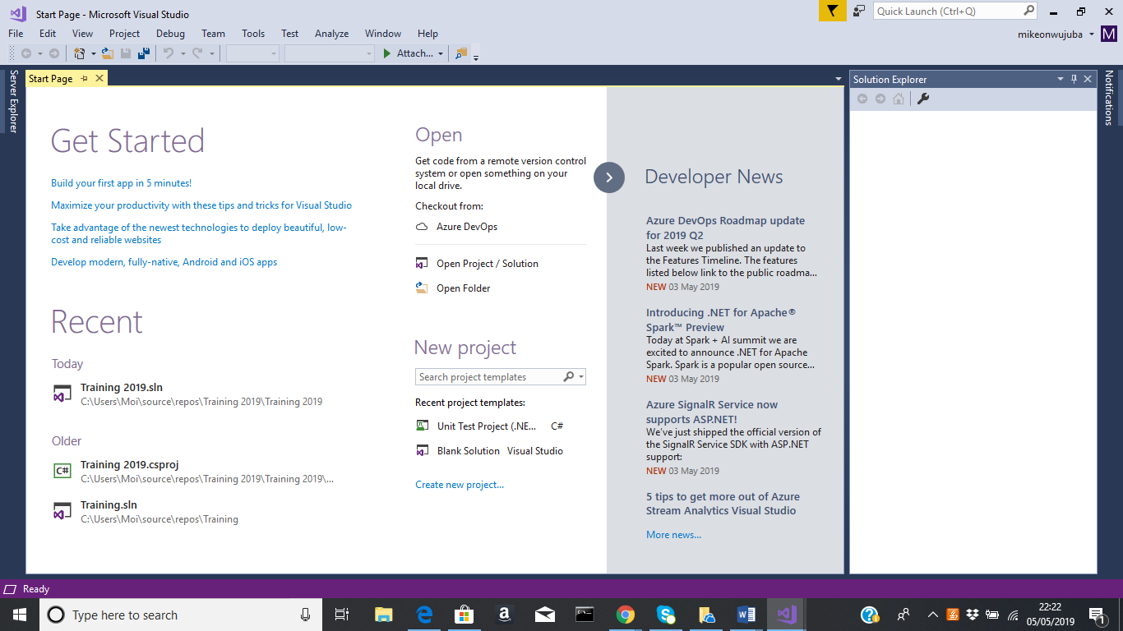

Intergrate specflow extension
Go to tools
Select extension and update
Select online
Search download specflow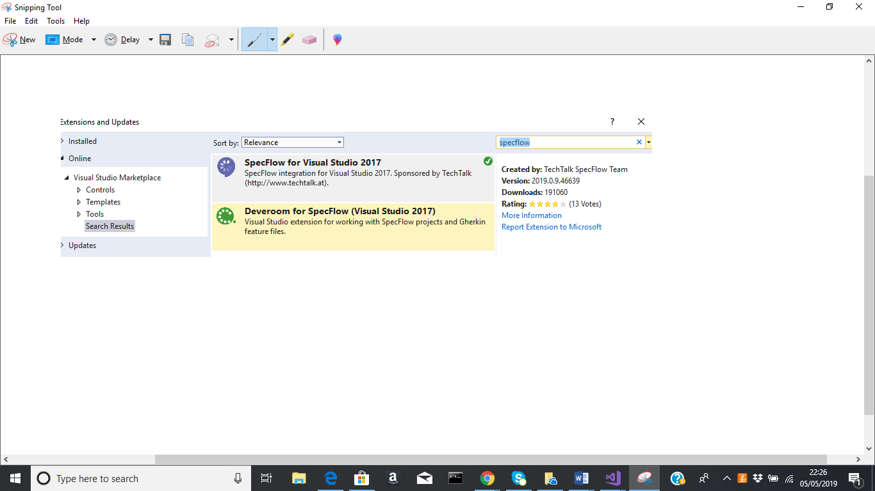

Create test case project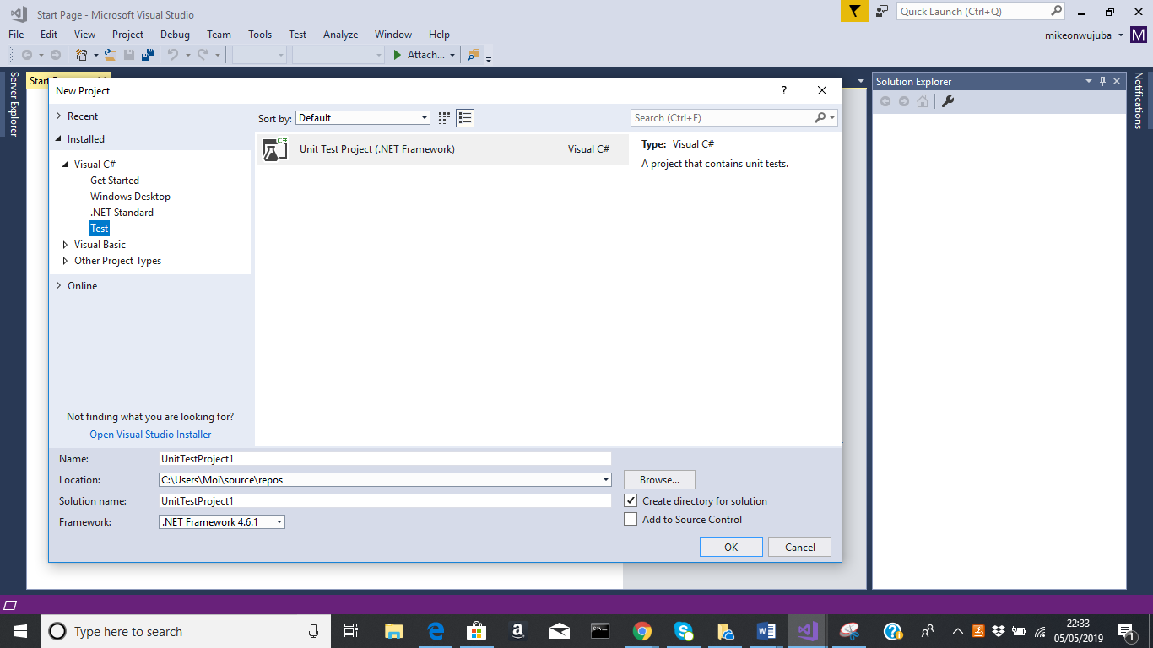
Create folder structures
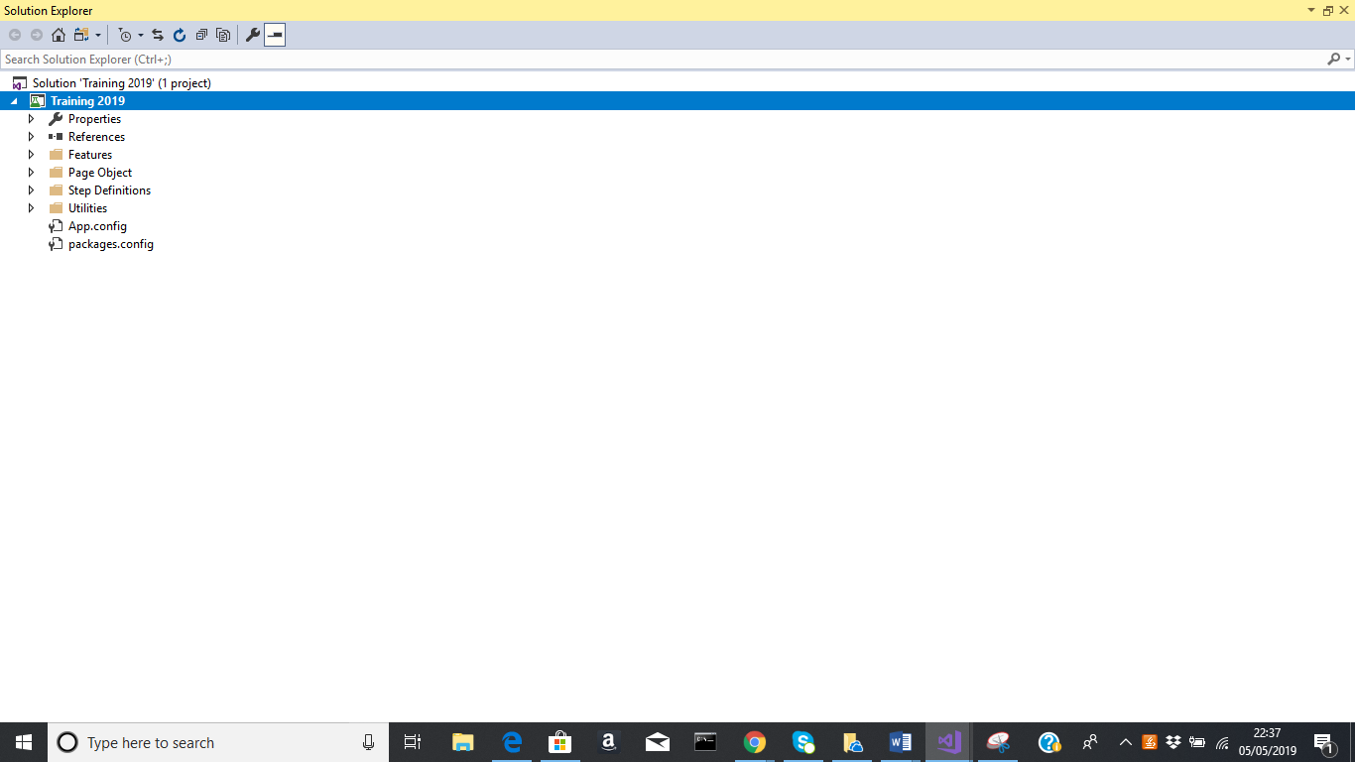

Nuget Packages
- In Solution Explorer, right-click References and choose Manage NuGet Packages.
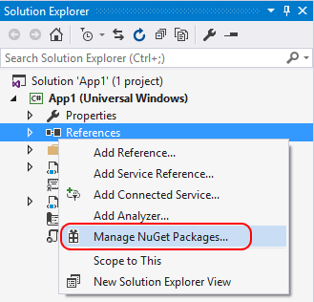
- Choose "nuget.org" as the Package source, select the Browse tab, search for Newtonsoft.Json, select that package in the list, and select Install:
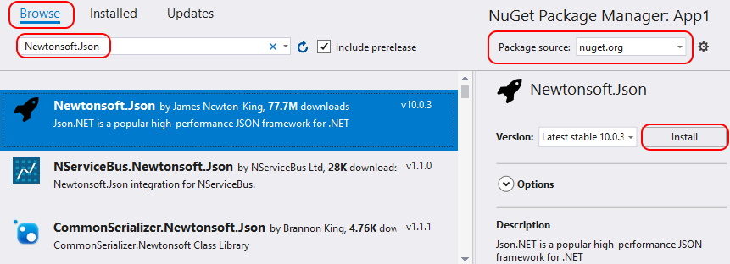
- Accept any license prompts.
- (Visual Studio 2017) If prompted to select a package management format, select PackageReference in project file:
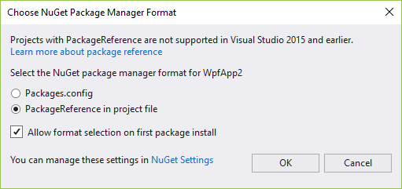
- If prompted to review changes, select OK.

Create feature files
Feature: Dashboard
As a giftrete web user
I want to be able to copy the referral link on my dashboard with ease
So that I can send it to friends and family for invite
Scenario: Dashboard
Given Am a giftrete web user
When I go to www.giftere.com
When I log in
And my dashboard is displayed
Then referrallink is displayed

Create stepdefinition
using System;
using TechTalk.SpecFlow;

namespace Training_2019.Step_Definitions
{
[Binding]
public class RegistrationsSteps
{
[Given(@"I navigate to the site")]
public void GivenINavigateToTheSite()
{
ScenarioContext.Current.Pending();
}

[When(@"I click on the register link")]
public void WhenIClickOnTheRegisterLink()
{
ScenarioContext.Current.Pending();
}

[When(@"I enter firstname")]
public void WhenIEnterFirstname()
{
ScenarioContext.Current.Pending();
}

[When(@"I enter lastname")]
public void WhenIEnterLastname()
{
ScenarioContext.Current.Pending();
}

[When(@"I enter email ""(.*)""")]
public void WhenIEnterEmail(string p0)
{
ScenarioContext.Current.Pending();
}

[When(@"I enter password")]
public void WhenIEnterPassword()
{
ScenarioContext.Current.Pending();
}

[When(@"I enter confirm password")]
public void WhenIEnterConfirmPassword()
{
ScenarioContext.Current.Pending();
}

[When(@"click on signup")]
public void WhenClickOnSignup()
{
ScenarioContext.Current.Pending();
}

[When(@"I click on the Login link")]
public void WhenIClickOnTheLoginLink()
{
ScenarioContext.Current.Pending();
}

[Then(@"I should be registered")]
public void ThenIShouldBeRegistered()
{
ScenarioContext.Current.Pending();
}

[Then(@"the registration page is not displayed")]
public void ThenTheRegistrationPageIsNotDisplayed()
{
ScenarioContext.Current.Pending();
}
}
}

Run the test

